Owings Homework Four

Final Cloud9 Project

10 May 2021

UMGC SDEV 400 7380

Professor Craig Poma

# Final Project Test Cases.

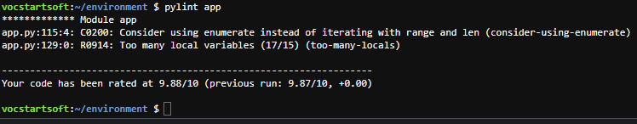

The user guide portion of this project was completed within the README.md file located within the environment file structure.

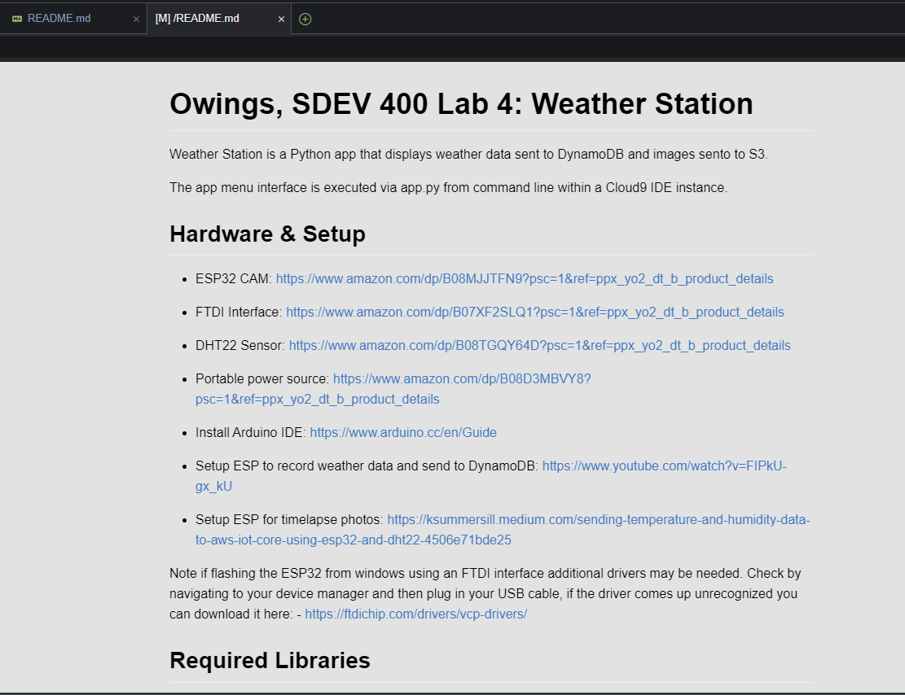

Note no-member was disabled in the. pylintrc file due to an unexplained error when calling the dynamodb.Table () function. Very little user input is needed for this app which made the test case amount smaller.

|  |  |  |  |  |
| --- | --- | --- | --- | --- |
| Test Case | Input description | Expected Output | Actual Output | Pass? |
| Test Case 1 | Start app and choose “a”, then choose “one”. | App should prompt user of incorrect entry and repopulate menu to try again. | See screenshots | Yes |
| Test Case 2 | Choose option 1. | App should populate latest temp and humidity data. | See screenshots | Yes |
| Test Case 3 | Choose option 2. | App should populate all temp and humidity data. | See screenshots | Yes |
| Test Case 4 | Choose option 3. | App should pull all temp and humid data and divide each(temp & humid) sum by the total count. | See screenshots | Yes |
| Test Case 5 | Choose option 4. | App should download the newest image based on “last modified” in S3 bucket and then populate a new image with the closest temp to when the image was taken. | See screenshots | Yes |
| Test Case 6 | Choose option 5. | App should download all images from S3 bucket and create an animated gif from those images. WARNING file is 100mb in size. | See screenshots | Yes |
| Test Case 7 | Choose q. | App should exit. | See screenshots | Yes |
| Misc | To send the temps and images to AWS s# and DynamoDB I needed to create a Lambda function, API Gateway, an IOT thing with rule and DynamoDB tables. There are two DynamoDB tables in screengrab one is the populated from JSON the other was made to store the sent data. The only difference is the temp/humidity data was populated as strings yet when sent in from device was sent as numbers. | | | |

|  |  |
| --- | --- |
| Screenshots | |
| Test Case 1 |  |
| Test Case 2 |  |
| Test Case 3 |  |
| Test Case 4 |  |
| Test Case 5 |  |
| Test Case 6 |  |
| Test Case 7 |  |
| Misc DynamoDB |  |
| Misc Lambda |  |
| Misc Lambda |  |
| Misc API |  |
| Misc IoT Core |  |
| Misc IoT Core Rule |  |

References

Amazon Web Services. (2021). *Amazon API Gateway.* Retrieved from https://docs.aws.amazon.com/apigateway/latest/developerguide/welcome.html

Amazon Web Services. (2021). *Amazon Web Services - Documentation.* Retrieved from https://github.com/awsdocs

Amazon Web Services. (2021). *AWS Documentation.* Retrieved from https://docs.aws.amazon.com/

Python Software Foundation. (2021). *The Python Language Reference.* Retrieved from https://docs.python.org/3/reference/